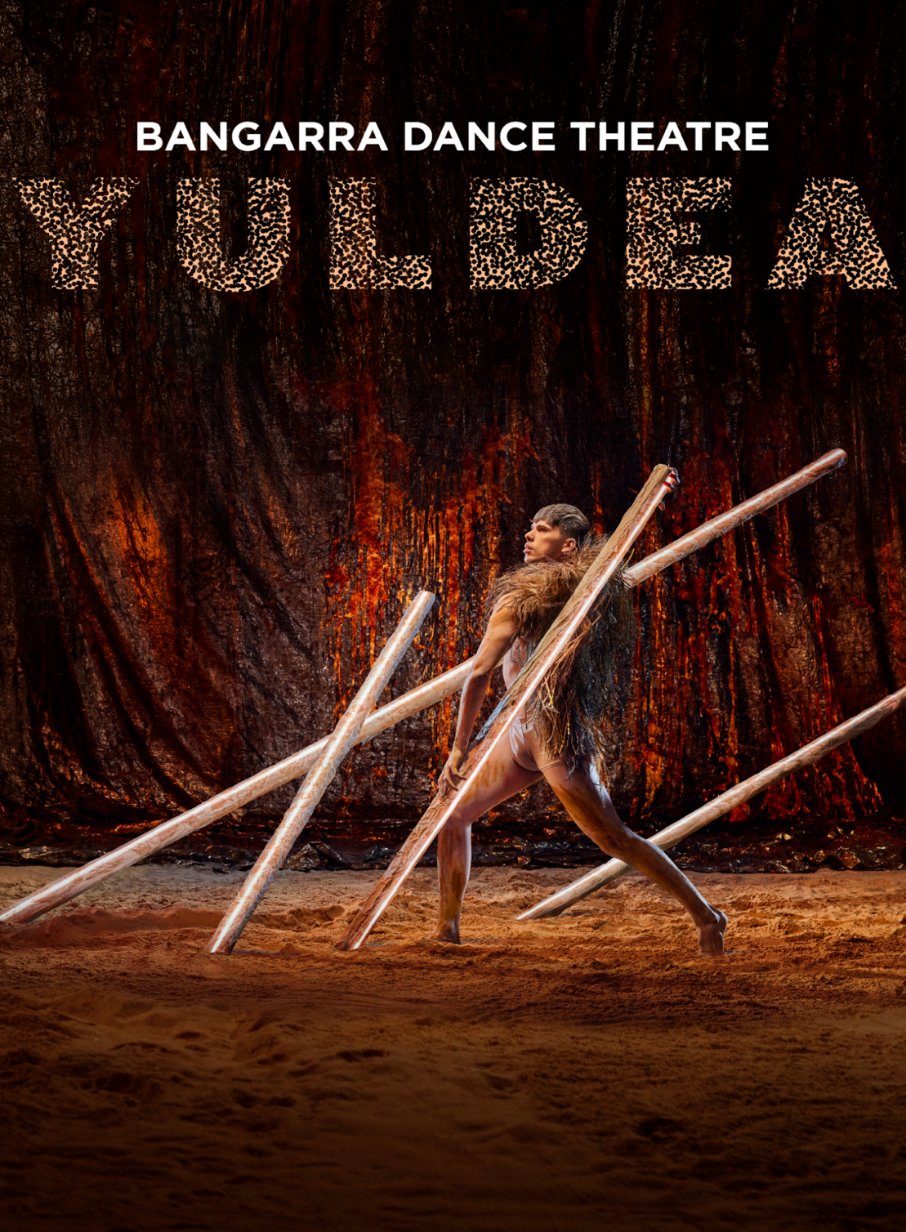
Easy-Read program
Image description: a male dancer stands in an open position facing the side, the right leg slightly bent, the other extended behind him. He is dressed in skin coloured under garments; his upper body covered in a fabric with emu feathers stitched to it. His body is painted with yellow and brown body paint. He stands amid four long poles that lean on a diagonal. The backdrop has a red and black sheen.

This Easy Read YULDEA program is a summary of a larger YULDEA program. You can find the larger program here or on our website.

You can ask for help to read this program. A friend, family member or support person may be able to help you.

ACKNOWLEDGEMENT

Bangarra Dance Theatre pays respect and acknowledges the Traditional Custodians of the Land which our Company calls home, the Gadigal People of the Eora Nation.

Acknowledgement means you understand that something is the truth, and that it is important.

Aboriginal and Torres Strait Islander readers are advised that this program contains the name of someone who has passed away.

WELCOME TO YULDEA

Yuldea is a dance theatre show that tells two stories about one special place.

One story is about the creation of the planet Earth, and how water came to Earth. This story also tells of the creatures and trees that knew how to find and store water in the desert, and about Aboriginal Culture staying strong through the spirit of the ancestors.

Ancestors are people who were in someone’s family a long time ago. Ancestors pass down their knowledge to younger people in their family so stories are not lost.

The other story is about important events that happened in the past, like the building of the Trans Australian Railway, the testing of atomic bombs in the desert at a place called Maralinga, and people called Missionaries who brought Christian religion to Aboriginal people.

ABOUT BANGARRA DANCE THEATRE.

Bangarra is a company of professional Aboriginal and Torres Strait Islander performers. We are storytellers. We are fire makers.
We share our culture with Communities and audiences across Australia and the world, drawing on our 65,000 years of Culture.
Bangarra was founded in 1989 by an American woman, Carole Y. Johnson. From 1991 to 2022, the company was led by cretive director, Stephen Page. Today, Artistic Director and co-CEO Frances Rings and Executive Director and co-CEO Louise Ingram lead the company in our mission to promote awareness and understanding of our First Nations cultures.
Every year, we tour a new show across the nation and sometimes overseas as well. We also perform in small venues in regional and remote places.
We exist for the hundreds of First Nations Communities across Australia — and for anyone who wants to be a part of our story.

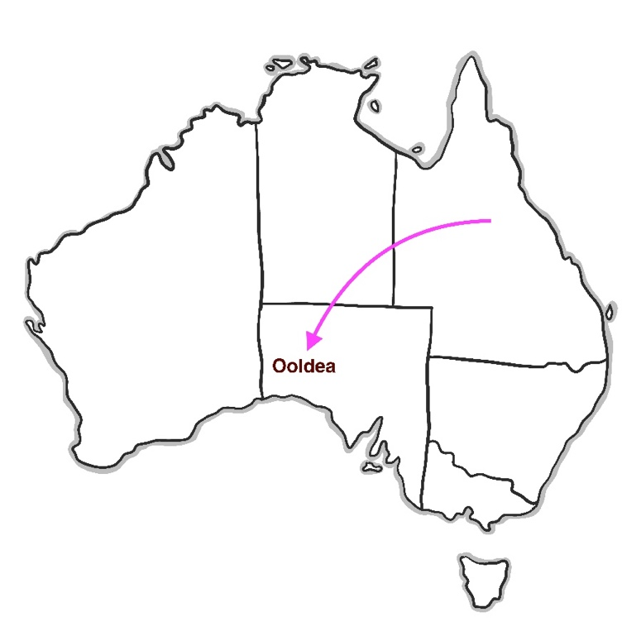  Image description: An outline map showing the shape of the Australian continent. A pink arrow points to the location of Yuldea (or Ooldea) in the lower part of the continent. |  |  |  | The People in the Story
 |  |  |  | Yuldea tells the stories of the Anangu people and the Nunga people of the far west region of South Australia. The Anangu and Nunga people suffered a great deal of displacement due to colonisation. Displacement is being moved from your home.
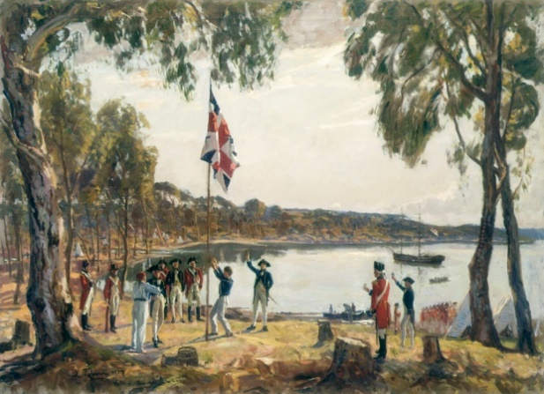  Image description: A group of military men are raising a British flag on the shore. The background shows bushland, a boat, and a bay of water. |  |  |  | Colonisation is when people start living on other people’s land without asking permission. Colonisation has happened all over the world. In Australia, colonisation started in 1788.
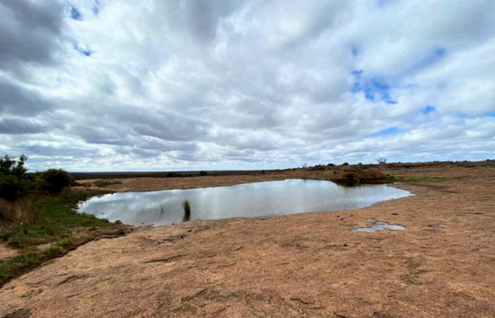  Image description: A large waterhole, several metres across, is seen in the desert against a background of blue sky and fluffy white clouds. |  | About Yuldea
 |  | Yuldea is the site of an important waterhole. This waterhole is surrounded by small sand hills and is called Yooldil Kapi, which is its traditional Aboriginal name. Aboriginal people travelled long distances from the western desert, and from the Nullarbor plain to gather at the Yuldea waterhole. They would come to trade tools and food, to arrange marriages, and to have special ceremonies.
The Story
Like many other parts of Australia, colonisation brought a lot of changes to the land around Yuldea and the traditional lives of the Aboriginal people who lived there before colonisation. Traditional means living in a way that your ancestors lived for thousands of years.
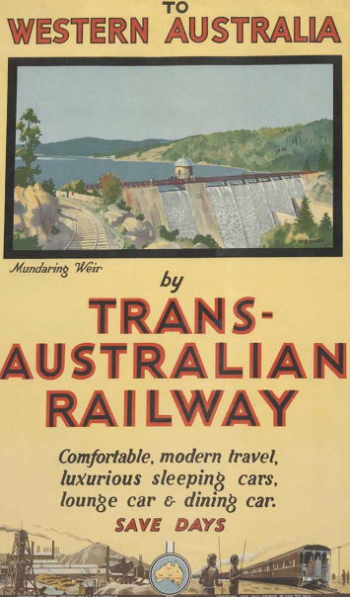  Image description: Poster from 1917 advertising the Trans Australian Railway. Two Aboriginal men holding spears are looking into the distance at the train. | One of the biggest changes to the lives of Aboriginal people who lived near Yuldea was the building of the Trans-Australian Railway.  Aboriginal people called this train the steel snake. The train was a steam train, so it needed lots of water to make steam for the engine. After a period of twenty years the waterhole was dry, because the trains used all the water.
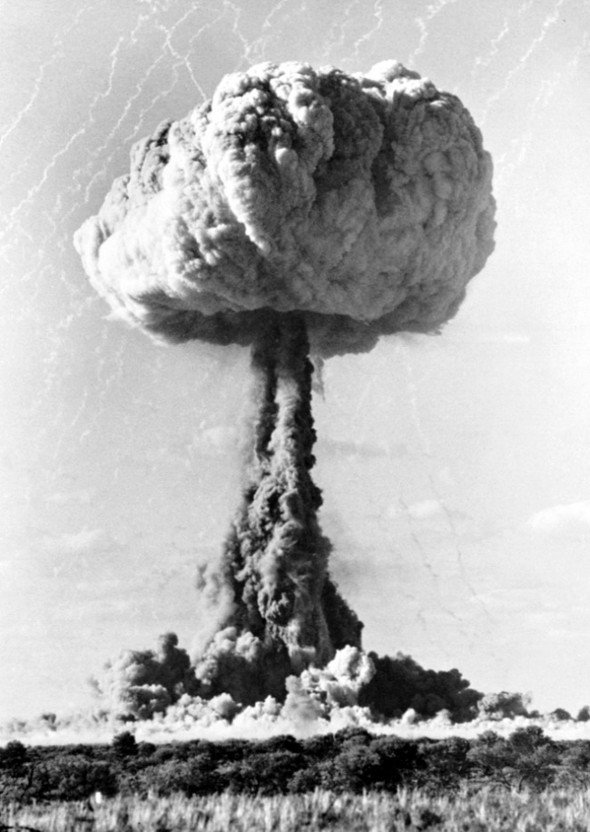  Image description: An atomic bomb explosion cloud of dust rises towards the sky and forms a mushroom shape at the top. |  |  | The other big impact on the Yuldea communities was the atomic testing that happened at a place called Maralinga. The Australian government allowed the British government to test their atomic bombs in the South Australian desert because they incorrectly decided it was uninhabited. But there actually were Aboriginal people living there. The government did not understand that Homelands are very important to Aboriginal people for their Cultural survival.  Uninhabited means nobody lives there.
 |  |  | .
Images

Below are the titles of the images, or description of the images used on pages 4 to 8, as well as the dates they were created.

Phillip R.N. Sydney Cove, Jan. 26th, 1788, by Algernon Talmage, 1937.

A colour engraving of a family of four travelling in the Port Jackson area based on sketches by S. Leroy.

A selector’s home in New England, 1890s.

Poster for opening of Trans Australian Railway, 1917.

Atomic tests – Atomic blast during operation Buffalo nuclear tests. Maralinga, south Australia with permission from national Archives of Australia.

The Sections in the Show

Supernova.
When a star explodes it creates new planets. This is how our planet Earth was created about 4 and a half billion years ago.

Kapi Spirit (Water)
About 3 and a half billion years ago, asteroids struck the earth bringing the chemical molecule H₂O that we call water.
Asteroids are small rock objects that fly around the sun.
A molecule is when atoms come together to form a chemical building block that forms a new material.

Water Finders.
Birds are very good at finding water that is not visible on the surface of the ground.
Dingoes can smell water. They scratch the ground to show people where to dig for underground water.
Red Mallee trees have very long and strong roots that can hold large amounts of water.

Letters Patent
A letters patent is a document that tells people if they have permission to start something official, like build a town or start using land for farming.

Steel Snake
This was the name Aboriginal people gave to the steam train that went across Australia and through the place called Yuldea.

Mission
For hundreds of years Christian people travelled to remote areas of Australia to spend time with Aboriginal Communities. They wanted to teach Aboriginal people about Christianity and spoke about civilising them to give them a better life. Civilising means learning how to live in a way that is often thought to be better and more advanced. Aboriginal people have good memories and bad memories of this time.

Black Mist
Black mist is what Aboriginal people called the black sticky ash from atomic bomb testing. The ash covered large areas around Yuldea. The ash was very poisonous and made many people sick, or blind or unable to have children.

Ooldea Spirit
The ancestors and old people of Yuldea are the keepers of the stories, both the Aboriginal stories and the historical stories about how colonialism affected them.

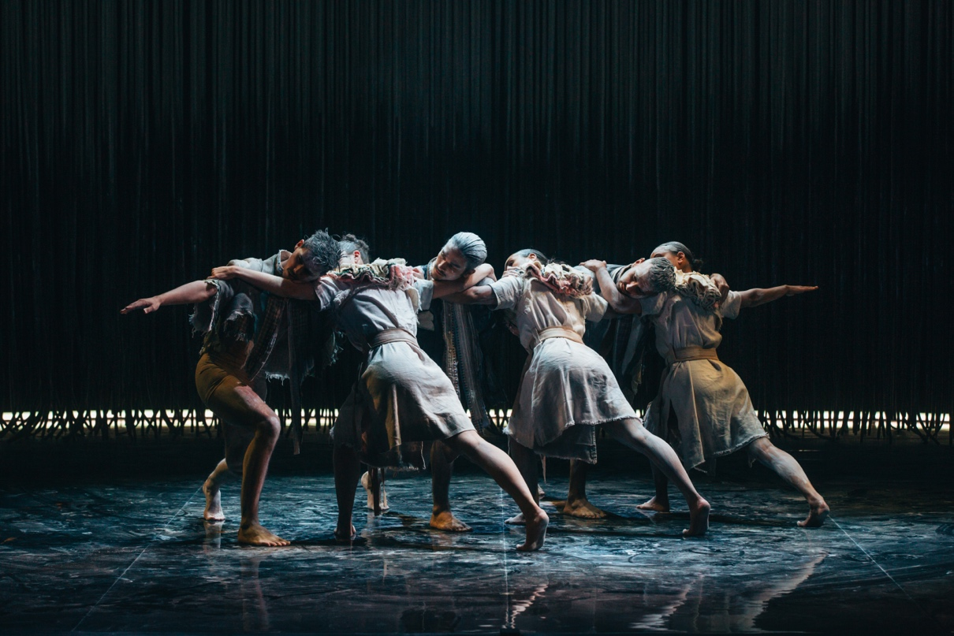

Photo by: Kate Longley

Image description: Image of six dancers – three men and three women. The women and the men face each other lunging forward with their arms reaching sideways so that their shoulders meet and arms interlock.

The women wear light coloured dresses, and the men are in loose pants to the knee and sleeveless shirts; the backdrop is black and there is a slither of light across the floor behind the dancers.

This is an image from the section Mission.

The Creative Team

The creative team is a group of people who create the productions that tell the stories. The team includes the people who choreograph the dance, make the music that the audience will hear, design what the stage will look like, decide what lights to use and design the costumes that the dancers wear.

The dancers work with the choreographer in the dance studio for many weeks to find the dance movements that will tell the story.

There are many other people on the creative team. The Rehearsal Director is in charge of practicing the movements each day with the dancers. Cultural Consultants also help create the work. Cultural Consultants are Aboriginal and/or Torres Strait Islander people who share their expert knowledge with the choreographer and the dancers.

These are the people in the Yuldea creative team:

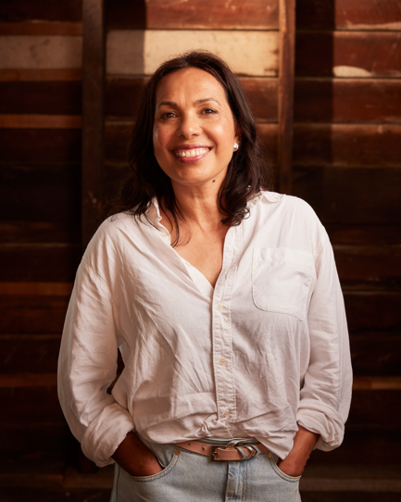 | Frances Rings | Choreographer
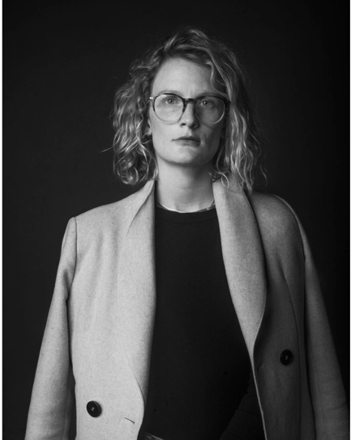 | Elizabeth Gadsby | Set Designer
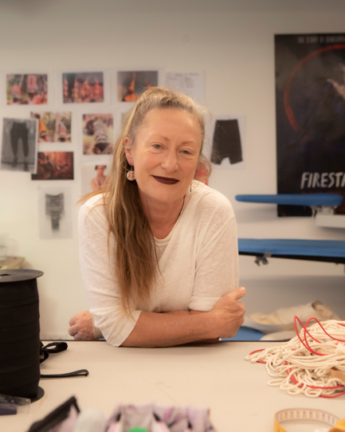 | Jennifer Irwin | Costume Designer
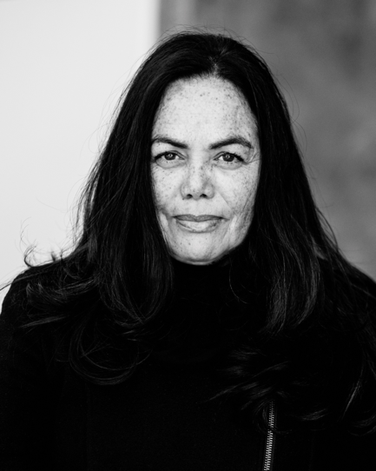 | Karen Norris | Lighting Designer
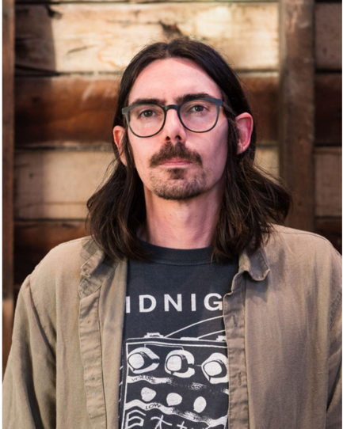 | Leon Rodgers | Composer
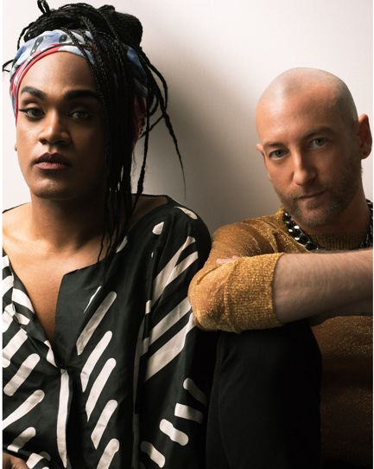 | Electric Fields | Guest Composers
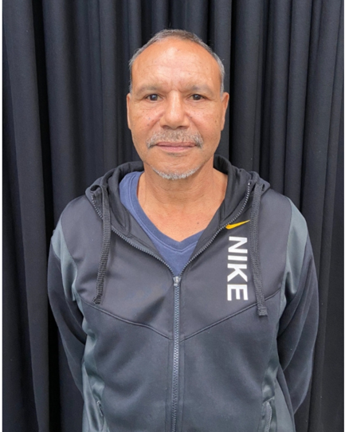 | Clem Lawrie | Mirning Cultural Consultant
No image available | Ms Smart | Yalata Cultural Consultant
No image available | Representatives from the Yalata Anangu Aboriginal Community Council | Cultural Authority
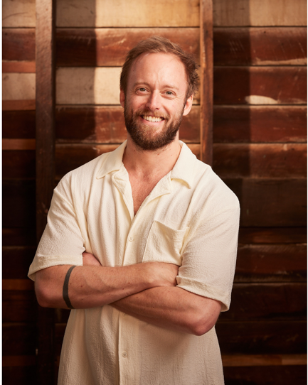 | Daniel Roberts | Rehearsal Director
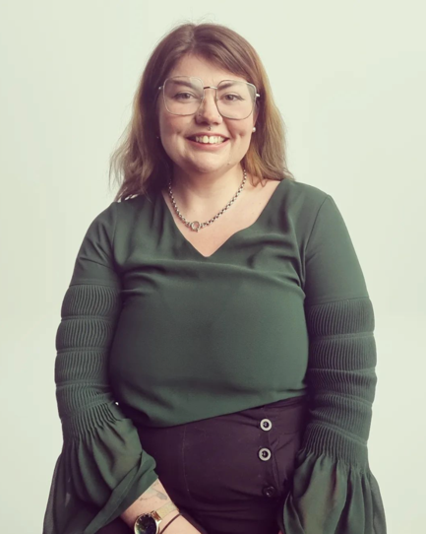 | Karlie Noon | Cultural Astronomy Consultant
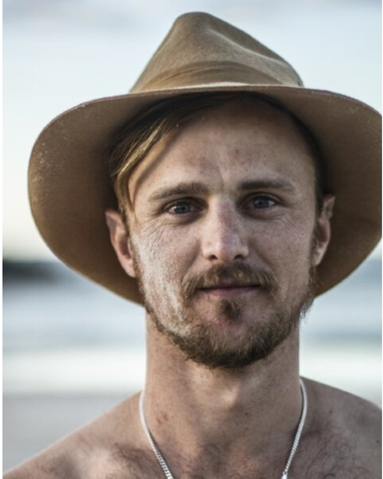 | Joshua Thomson | Aerial and Acrobatic Consultant

These are the dancers who perform in the show. As well as their name, their cultural background is written. All the dancers at Bangarra are from Aboriginal and/or Torres Strait Islander background and are wearing pale brown and white loose clothing and are standing in front of a timber wall.

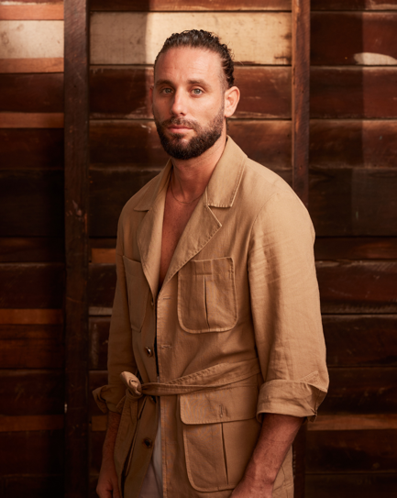 | Rikki Mason | Kullili descendant from Queensland
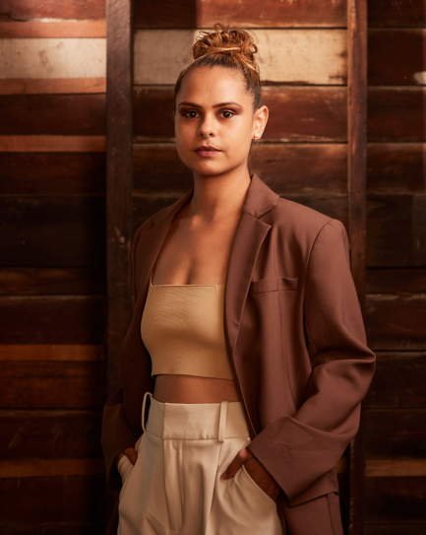 | Lillian Banks | A proud Yawuru woman from Broome, Western Australia
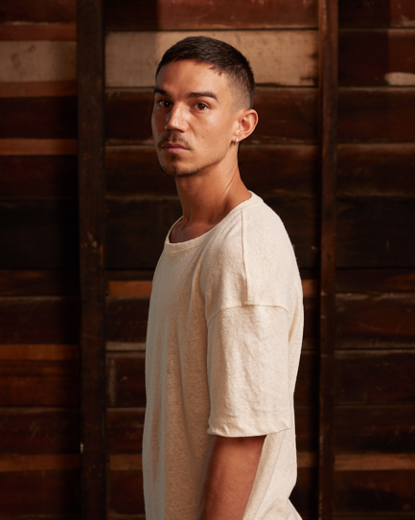 | Bradley Smith | A proud Gumbaynggirr man from New South Wales
 | Courtney Radford | Balardong descendant from Western Australia
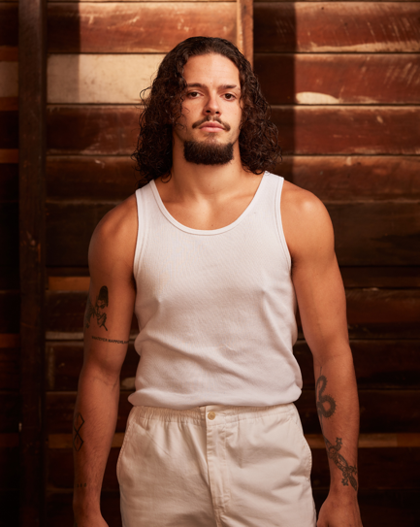 | Kallum Goolagong | A proud Wiradjuri and Darkinjung man from New South Wales
 | Kassidy Waters | Wanaruah descendant from New South Wales
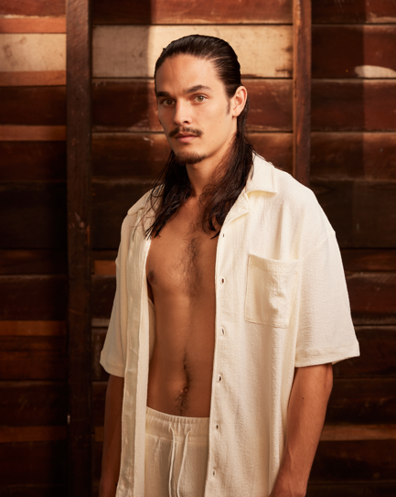 | Kiarn Doyle | A proud Aboriginal man from the Dunghutti Nation in New South Wales
 | Maddison Paluch | Wiradjuri descendant from New South Wales
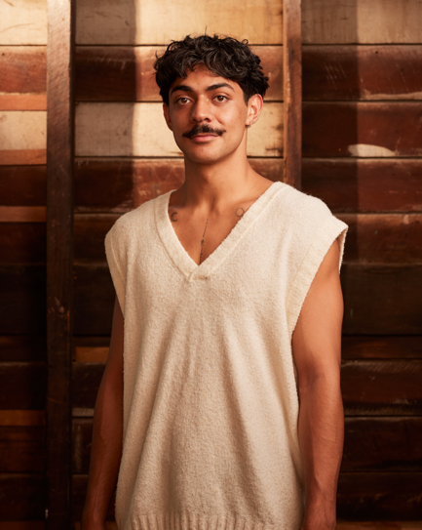 | Daniel Mateo | Gamilaroi descendant from New South Wales
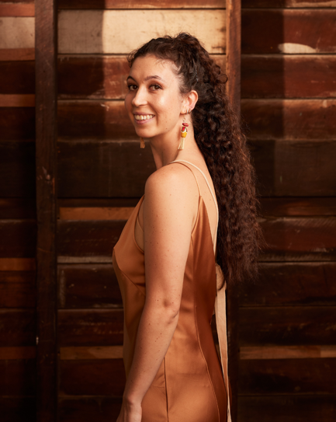 | Emily Flannery | A proud Wiradjuri woman from New South Wales
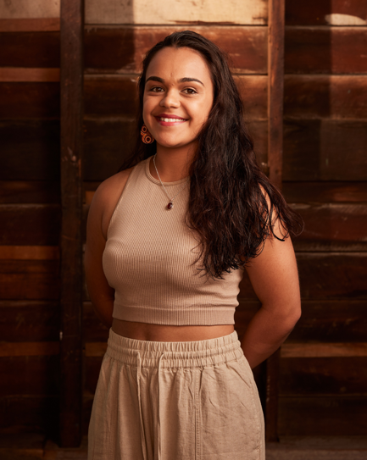 | Janaya Lamb | Wiradjuri and Torres Strait descendant from New South Wales
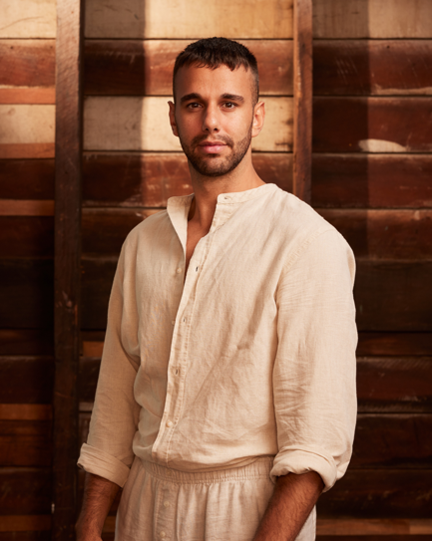 | James Boyd | A proud Aboriginal man with connections to Kunja and Muruwari people and Wakka Wakka Nation from New South Wales and Queensland
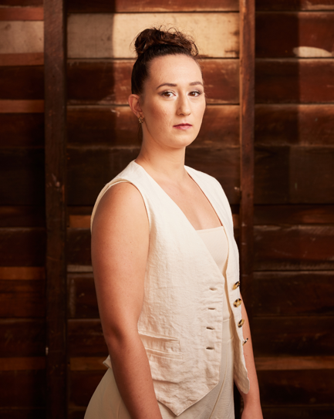 | Chantelle Lee Lockhart | Dharawal and Eora descendant from New South Wales
 | Amberlilly Gordon | A proud Wiradjuri and Ngemba woman from New South Wales
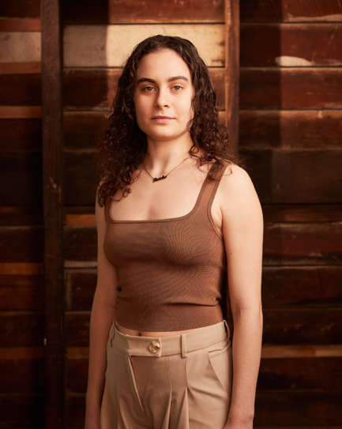 | Lucy May | A proud Dunggalaba, Kulumbirigin and Tiwi woman from the Northern Territory
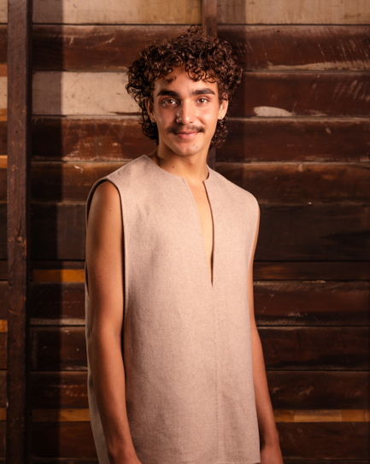 | Donta Whitham | A descendant of the South Sea Islands with Ambrym Island connections on his mother’s side and Sri Lanka background on his father’s side.
On Country

Bangarra tells stories through dance. Before creating the dance, the creative team and the dancers go to the place where the story comes from. This is called going On Country. A great deal of time is spent walking on Country, listening to stories, sharing food, and learning about the history of the place.

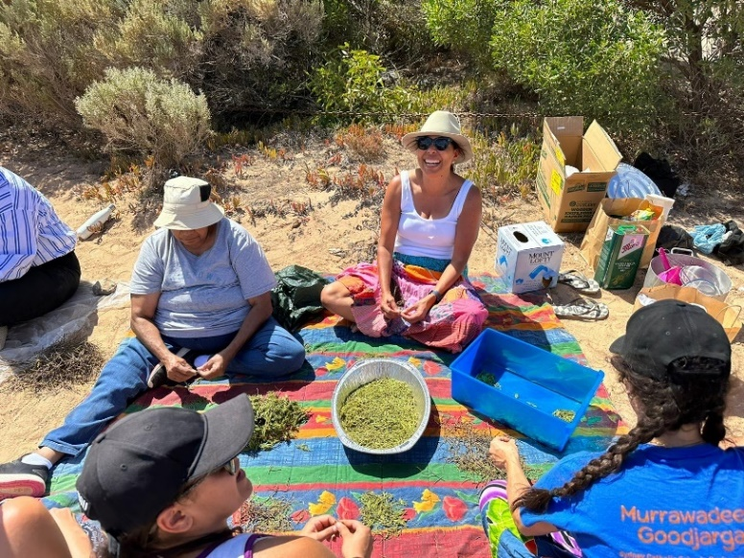

Image description: Four people sitting on a coloured piece of cloth on the desert ground focusing on a bowl of bush medicine leaves in the centre of the cloth.

One woman is wearing a colourful skirt, white singlet, straw hat, and sunglasses, and is looking up smiling. They are On Country, where they spend time with Community – listening to stories and learning about the Land.

Headshots by Daniel Boud and Jacquie Manning.
Promotional image by Daniel Boud.
On Country photography by Rikki Mason and Kassidy Waters.

Bangarra Dance Theatre
Gadigal Country, Eora Nation
Wharf 4/5, 15 Hickson road
Walsh bay NSW 2000
Phone +61 9251 5333
Email bangarra@bangarra.com.au

www.bangarra.com.au

@bangarradancetheatre #bangarra
/bangarra
@bangarradance
/bangarradancetheatre

